Annual Progress Report

2011

Strengthening Election Management
in Bangladesh (SEMB)


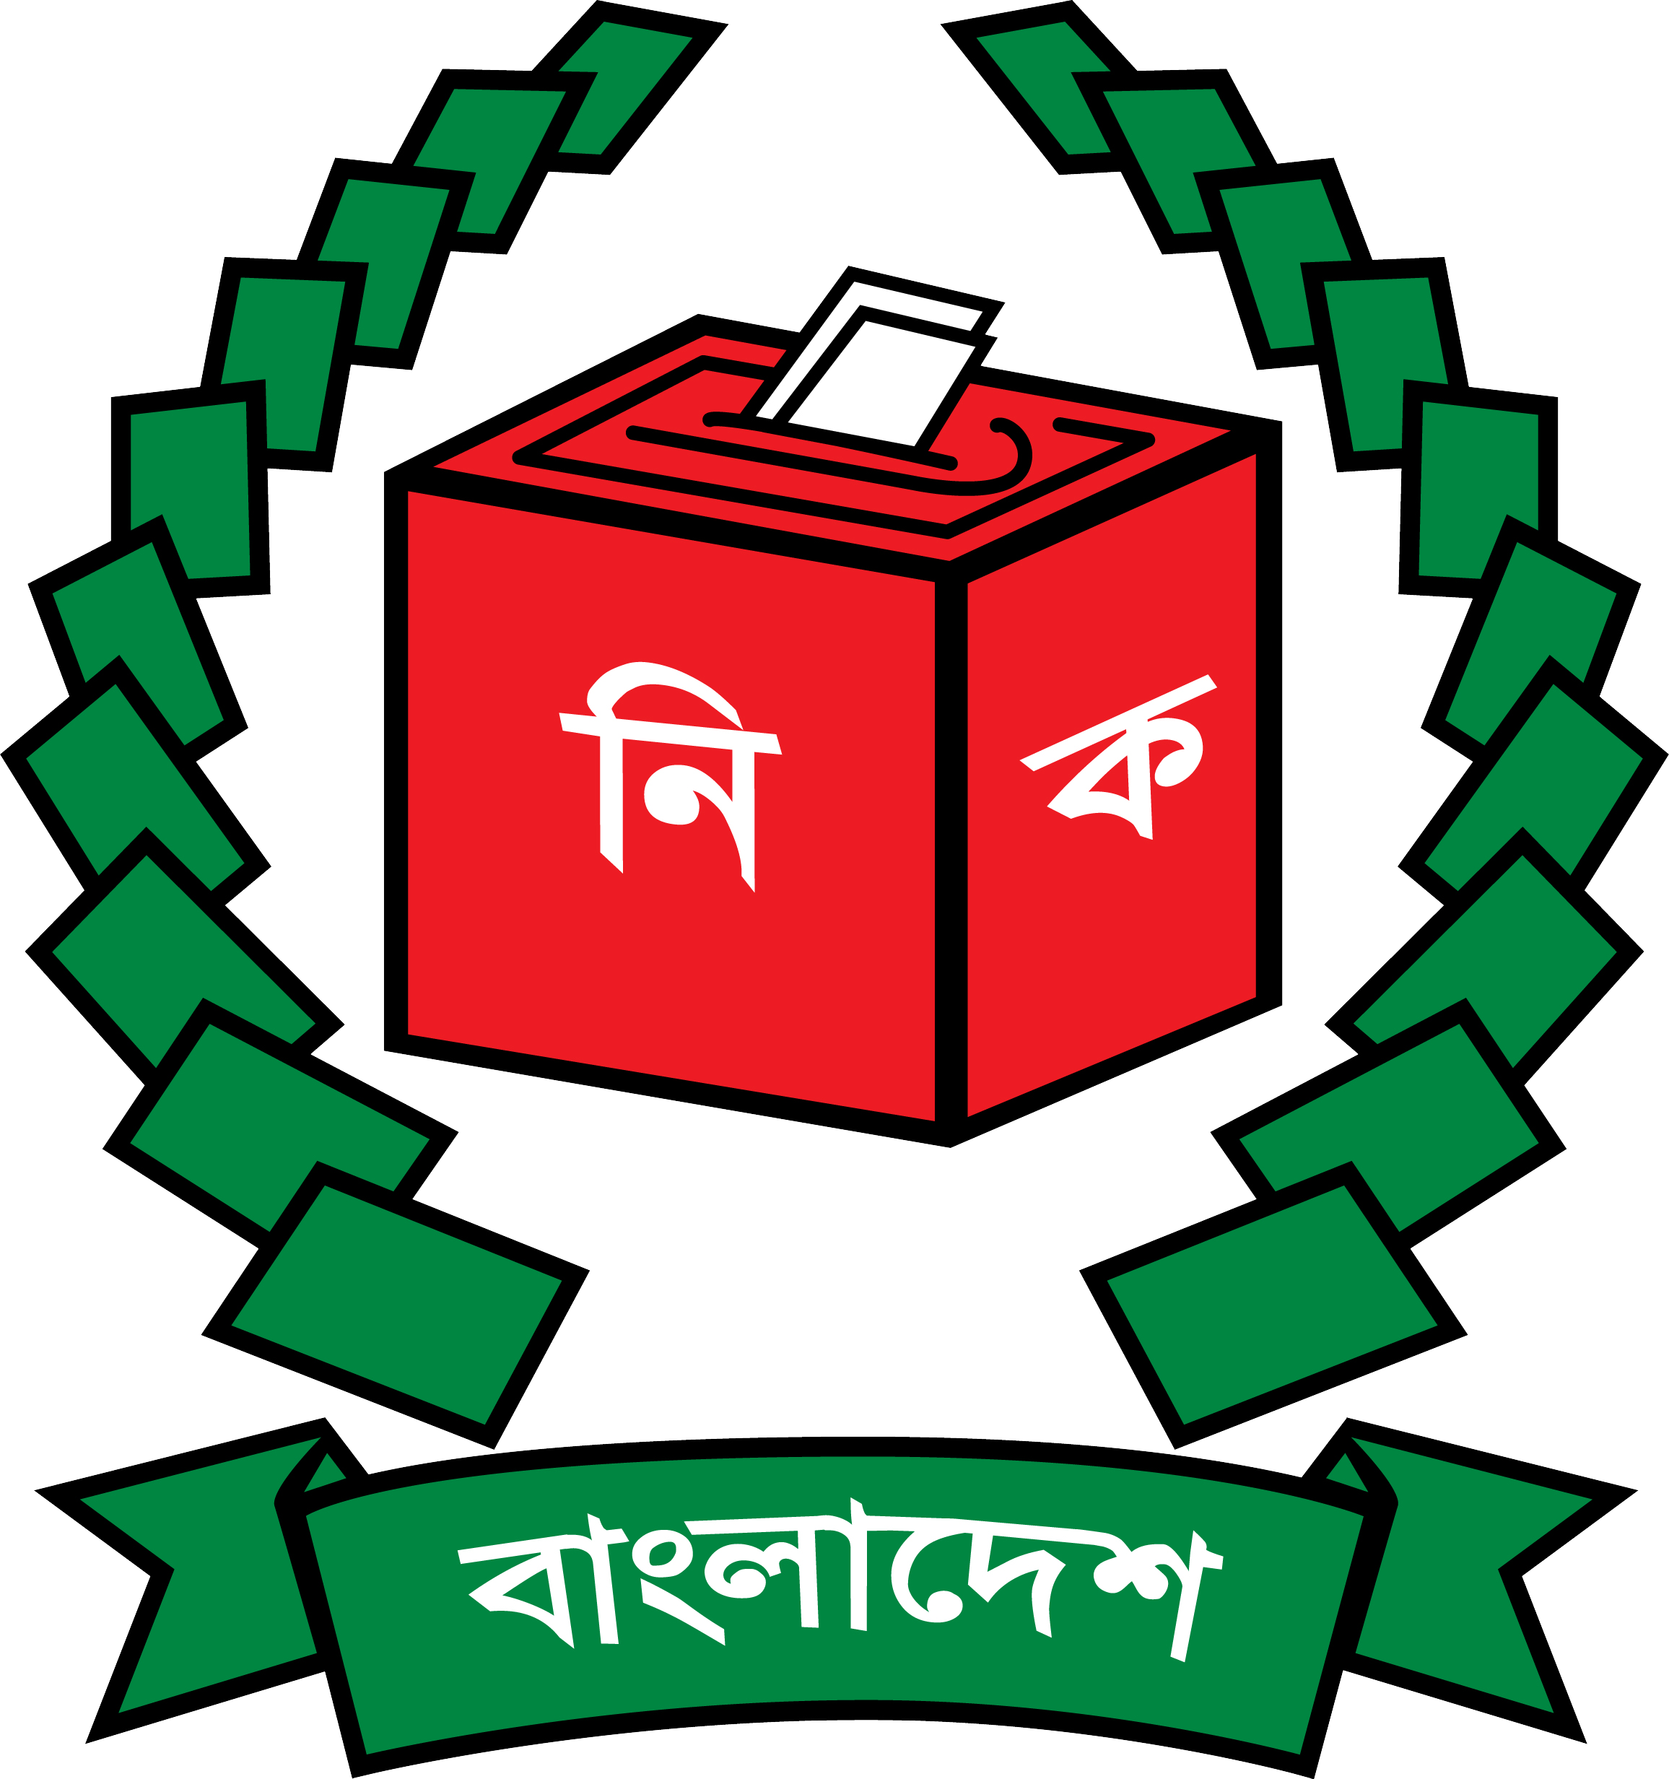

Bangladesh

January 2012
Country Bangladesh

ANNUAL PROGRESS REPORT (July - December 2011)

No. and title of the Programme/project No. 00078498; Strengthening Election Management in Bangladesh (SEMB)

Executing Agency Bangladesh Election Commission

Project Period April 2011 – March 2016

Reporting period July - December 2011

Reporting Agency UNDP Bangladesh

Project Goal To enhance and further consolidate the institutional and professional capacities of the BEC, its Secretariat and local offices to deliver its mandated functions of conducting fair, credible and transparent elections and further consolidating itself as a permanent, professional, credible and independent institution of governance.

Project Purpose To provide technical assistance to the BEC, its Secretariat at headquarters and regional and sub regional levels in order to further strengthen capacity at all levels which will combine to form a comprehensive package leading into the parliamentary elections in 2014.

Management Arrangement National Exécution (NEX)

Contact Person Md. Abdul Alim, Project Coordinator
(Ph: 9111885, E-mail: alim3492@yahoo.com)

List of Acronym

AWP Annual Work Plan
BEC Bangladesh Election Commission
CEC Chief Election Commissioner
CSSED Construction of Server Stations for Electoral Database
DCS Direct Country Office Support
DEC Deputy Election Commissioner
DEX Direct Execution
DFID Department for International Development
ERD Economic Relations Division
ETI Electoral Training Institute
EU European Union
EVM Electronic Voting Machine
ICT Information Communication Technology
GoB Government of Bangladesh
NEX Nationally Executed
NNEB Network for National Election Management Bodies
NPD National Project Director
PERP Preparation of Election Rolls with Photograph
PSC Project Steering Committee
PIC Project Implementation Committee
QWP Quarterly Work Plan
SBS Step by Step Guide
SEMB Strengthening Electoral Management in Bangladesh
SEPB Support to the Electoral Process in Bangladesh
UNDP United Nations Development Programme
USAID United States Agency for International Development

Table of Contents

Content Page
Executive Summary 5

Section 1: Context
1.1 The key developments and issues related to election in Bangladesh 6
1.2 Description of the key activities and outputs of the SEMB 7

Section 2: Results Reporting
Introduction 9
Progress Towards Outputs and Targets 9

Section 3: Key achievements 12

Section 4: Lessons Learnt 17

Section 5: Way Forward 18

Annexure 19

Executive summary

Strengthening Election Management in Bangladesh (SEMB) is a five-year technical assistance project consists of technical assistance designed to enhance and further consolidate the institutional and professional capacities of the Bangladesh Election Commission (BEC), its Secretariat and local offices to deliver its mandated functions of conducting free, fair, credible and transparent elections and further consolidating itself as a permanent, professional, credible and independent institution of governance. SEMB is a Nationally Executed (NEX) project officially started from 01 April 2011. It is a multi-donor project funded by 4 development partners, i.e. European Union (EU), United States Agency for International Development (USAID), UK Department for International Development (DFID) and United Nations Development Programme (UNDP). Except contribution from development partner, there is some GoB contribution in the project.

Although, the project officially started from April 2011, the Annual Work Plan (AWP) for 2011 has been prepared for July-December 2011 period. The key activities done in July – December are:

- Inception meeting of the project
- Dissemination Workshop on Five years Strategic Plan and Two years Action Plan of BEC in Chittagong
- Post Union Parishad Election Evaluation Workshop in Chittagong
- Organizational Development Workshop of BEC
- Piloting of Voter list Update in four areas of Bangladesh
- Project Implementation Committee (PIC) meeting
- Expediting the recruitment process
- Renovation of new office space of Electoral Training Institute (ETI)
- Renovation work to shift to a new office space for the project
- Preparation to initiate BRIDGE training
- Participate General Assembly of the Association of Asian Election Authorities (AAEA) in Korea
- Campaign activity to introduce and popularize Electronic Voting Machine (EVM) in Narayanganj City Corporation Election 2011
- Mayoral Candidate debate with contesting candidates of Narayanganj City Corporation in Bangladesh Television
- Installation of CCTV camera for online monitoring and security management of Narayanganj City Corporatoin (NCC) election 2011
- Workshop on Digital filing with participation of BEC officials, 17 December 2011
- Dissemination Workshop on Five years Strategic Plan and Two years Action Plan of BEC in Dhaka
- Post Union Parishad Election Evaluation Workshop in Dhaka

Section 1: Context

1.1 The key developments and issues related to election in Bangladesh

Election management is a never-ending pursuit that constantly strives for perfection regardless of the occasional setbacks. Elections do not take place in isolation, as they require the involvement and participation of a wide range of stakeholders whose own interests should also coalesce to ensure a free, fair and credible process. Therefore, it is also important to recognize that while elections are an important activity they are also only one aspect within the broader context of democratic good governance.

Elections are one of the most important ways citizens can participate in decisions that affect their lives and hold their representatives accountable for results. Although it is the foundation stone for bringing democracy in a country, a free, fair, transparent and credible election is very pivotal. Bangladesh Election Commission (BEC), a permanent constitutional body, is the responsible authority for managing elections in Bangladesh. The Constitution has vested in the Commission the superintendence, direction and control of the entire process for conduct of all elections and, in the exercise of its functions, the Commission is independent and subject only to the Constitution and the relevant laws. The spirit of the Constitution in terms of independence of the Commission is duly captured in the Election Commission Secretariat Act, 2009. This Act has severed organizational links of the Commission Secretariat with the Prime Minister's Office and the Secretariat is not under the control of any Ministry or Division. On behalf of the Commission, the Ministry of Law, Justice and Parliamentary Affairs take care of its legal needs. The Constitution mandates the following responsibilities to be performed by the Commission:

a. hold elections to the office of the President;
b. hold elections of members of Parliament;
c. delimit the constituencies for the purpose of elections to Parliament; and
d. prepare electoral rolls for the purpose of elections to the office of President and to Parliament.

In line with the United Nations Development Programme’s (UNDP) mandate to work in developing countries in the areas of professional development and democratic governance the country office has had long standing cooperation with the BEC. Support during preparations for the 2008 elections was increased significantly through a basket fund of international development partners in Bangladesh and UNDP’s role in administering this fund has further acted to cement partnerships in support of the electoral process.

The BEC and UNDP country office in Bangladesh have worked closely in support of the electoral process during the past electoral cycle. Four nationally executed projects (NEX) have provided long term support to the elections in four main areas. These projects are 1) preparation of the electoral roll with photographs (PERP) 2) support to the electoral process in Bangladesh (SEPB) 3) construction of server stations for electoral database (CSSED) and 4) translucent ballot boxes project (TBB). Support also provided to BEC through Preparatory Assistance to Strengthening Electoral Reform in Bangladesh (PA to ER), a DEX project worked as a bridging phase between SEPB and the newly initiated Strengthening Election Management in Bangladesh (SEMB) project.

Following a series of reforms initiated by the Commission through those projects, including political party reforms, the BEC held a highly credible and transparent election in December 2008. The election has been claimed the best election in the country’s history. In the post-election environment, the Election Commission remains focused on electoral reforms working to ensure its remaining time in office results in greater transparency, credibility and professionalism in the conduct of elections. In order to provide support to the post-election reform activities and further consolidate the institutional and professional capacities of the BEC, a new five-year technical assistance project entitled Strengthening Election Management in Bangladesh (SEMB) has been initiated.

1.2 Description of the key activities and outputs of the SEMB
The key objectives of the project are to enhance and further consolidate the institutional and professional capacities of the BEC, its Secretariat and local offices to deliver its mandated functions of conducting fair, credible and transparent elections and further consolidating itself as a permanent, professional, credible and independent institution of governance. In order to achieve the objectives, the project has the following outputs:

Output 1: Professionalised and strengthened training by the BEC
Output 2: Strengthened BEC capacity to efficiently manage decentralisation and institutional growth
Output 3: Reformed communications unit and outreach to stakeholders
Output 4: Professionalised and strengthened ICT wing of the BEC
Output 5: Enhanced capacities to prepare and disseminate a credible and accurate photo voter register
Output 6: Support to activities in the run up to the parliamentary elections in 2012

The activity result of output-1 is to reform of training department of the BEC for professionalised training delivery for skills development of BEC staff, temporary BEC employees, and external stakeholders, to provide improved BEC institutional capacity and election performance.

Through the implementation of output-2, the BEC will have a strategic plan, will be innovative in developing its practice, and will be operating with improved efficiency at central and field level. The organisation’s internal administration will be modernised and research conducted for assessments on potential areas for innovation in election delivery.

Output-3 has targeted the reform of the communications unit of the BEC and the creation of a modern communications arm capable of delivering internal and external communication on a regular basis allowing for better management of media and other relations and increased transparency in the electoral process. This activity will institutionalise outreach to stakeholders and enable the unit to arrange regional and national external affairs.

The activity result of output-4 is to enhanced capacity to integrate and utilise Information Communication Technologies (ICT) in election management. Through the implementation of output-5, the BEC will have a system of continuous voter registration delivered at Upazila level offices and backed up by a robust and fully featured Bangladesh voter registration management system (BVRS).

Support to activities in the run up to the nest parliamentary elections will account for the short term activities undertaken by the BEC and stakeholders during the 90 day period following the dissolution of parliament and election day itself. It will include assistance to the BEC to organise candidate debates across the country, measures to monitor compliance to regulations and laws, media monitoring by civil society groups as well as large scale training activities for the BEC’s own permanent and temporary staff as well as other stakeholders involved in the electoral process.

Section 2: Results Reporting

2.1 Introduction

This section of the report contains the achievements and results in 2011. Although 2011 was initiation year for the project and the AWP was prepared for six months, project achieved some results.

2.2 Progress Towards Outputs and Targets

The following matrix describes the progress against each output along with the indicators and targets as described in the Country Programme Action Plan (CPAP).

CPAP outcome | CPAP indicators | CPAP targets | Progress towards output targets
Electoral assistance coordinated and electorate informed of voting rights and responsibilities. | Modified code of conduct published. Number of legal documents revised.  Voters’ list updated and database corrected.  Number of official exposed to electoral systems and processes in the region.  Number of electoral officials trained. Electoral Training Institute (ETI) supported.  Number of civil society organisations involved in observing the elections.  Number of media coverage of debates and voter information. | Legal reforms of the BEC.  Voter database maintained.  Strengthened capacity of the BEC.  Voters’ rights and civic awareness enhanced.  Election information made available to all stakeholders.
Output 1 | Indicators | Target | Progress towards output targets
Professionalised and strengthened training by the Election Commission Secretariat. | Progress made towards the formulation of a strategic plan for the ETI.  Number of election officials certified as BRIDGE facilitators. | Draft ETI strategic plan and calendar finalised for approval of Commission.  Furnished ETI offices.  Training module drafted.  Number of officials trained.  Furnished library. | ETI offices refurbished and fitted out.
Output 2 | Indicators | Target | Progress towards output targets
Strengthened BEC capacity to efficiently manage decentralisation and institutional growth. | Financial system established.  HR management system established.  Number of workshops/conferences arranged. | Three activities implemented under BEC’s five year strategic plan. | Detailed functions and job descriptions of the departments of the BEC have been finalised and 5,000 copies distributed.  South-south cooperation strengthened with joint conference with the Commonwealth for election officials in Dhaka organised.  Three workshops to review post election lessons learnt were organised for 300 election officials.
Output 3 | Indicators | Target | Progress towards output targets
Reform of communications and strengthening partnerships. | Developed action plan.  Furnished documentation centre.  Printed visitors programme.  Number of officials trained.  Number of newsletters printed. | Two quarterly newsletters distributed. | Two quarterly newsletters printed and 4,000 distributed.  BEC action plan disseminated to 195 local election officials through a dissemination workshop.
Output 4 | Indicators | Target
Professionalised and strengthened IT wing of the ECS. | Number of officials trained.  LAN and WAN appraisal report.  ICT strategic plan. |  | No activities or results for 2011.
Output 5 | Indicators | Target | Progress towards output targets
Enhanced capacities to prepare and disseminate credible and accurate voter list. | Updates to voter list in four pilot areas.  Number of officials trained on voter registration system.  SOPs finalised for voter register updates.  Finalised voter registration process. | Updates to voter list in four pilot areas.  SOPs finalised for voter register updates.  Finalised voter registration process. | Voter list in four pilot areas updated and verified.  Finalised procedures and SOPs for voter registration updates.
Output 6 | Indicators | Target | Progress towards output targets
Support to activities in the run up to the parliamentary elections in 2013. | Printed step by step manual.  Training assessment report. |  | Election online monitoring and security system piloted in the Narayanganj City Corporation election to monitor vulnerable polling stations.

Section 3: Key Achievements

The year 2011 is the take-off period for the project. Project has taken a series of activities for smooth inception of its journey, though it has gained a number of achievements both in general and specifically. In general, the project resulted in several important outputs:

- Improved and better management of local level elections especially Union Parishad (UP) Elections 2011. Post UP election workshops were organized to document the knowledge and experience of relevant field level officers of Dhaka, Chittagong and Comilla region.
- BEC officials’ knowledge enriched with dissemination workshop on Five years Strategic Plan and Two years action plan.
- Piloting of voter list updating in 4 areas of Bangladesh
- Electoral Training Institute (ETI) moved to a new office space, renovation and workstation
- Documented and well-planned organizational job description for BEC
- Introduction and popularization of EVM in Narayanganj City Corporation Election 2011
- Installation of CCTV camera for online monitoring and security management in Narayanganj City Corporation Election 2011

On the other hand, there were many specific achievements which impacted on outputs. Some key of those achievements have been described below:
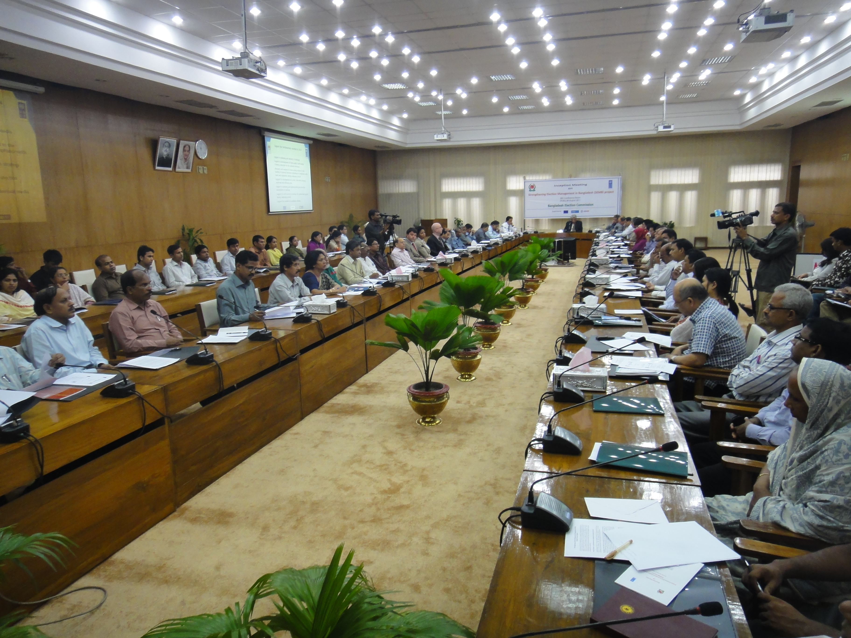
- Inception meeting: Inception meeting of the project held on 8 August 2011 at NEC conference room, Dhaka. The meeting was organized to share the project’s details with CSOs, NGOs and media representatives who are actively engaged with electoral process in various level of Bangladesh. Dr. ATM Shamsul Huda, Chief Election Commissioner of BEC, Mr. Stefan Priesner, Country Director of UNDP Bangladesh and relevant stakeholders were present in the meeting.
Photo: Audience of the inception meeting

- Post UP Election Evaluation workshop: A day long workshop held on 17 August 2011 in LGED auditorium, Chittagong with participation of election officials of various level of Chittagong and Comilla region. A total of 64 Election officials participated from Chittagong, Bandarban, Rangamati, Khagrachari, Cox’sbazar, Comilla, Feni, Laxmipur, Chadpur, Brahmanbaria, Noakhali districts. Participants evaluated recently held Union Parishad election in all over Bangladesh through a structured questionnaire in step by step manner. Participants of the workshop pointed out important findings and recommendations about the election which will specifically guide to arrange local level elections in future.

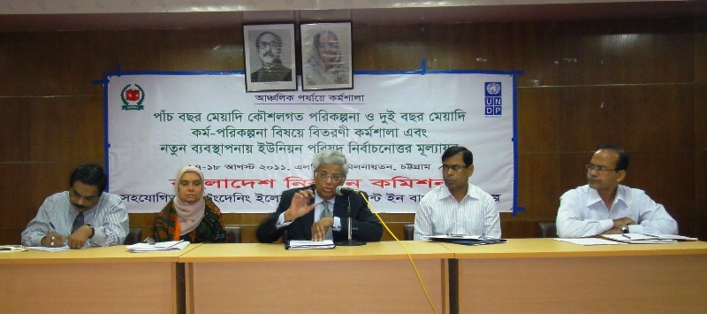

Photo: Dr. ATM Shamsul Huda, Chief Election Commissioner delivering lecture in the workshop

A similar workshop was organized on 27 December 2011 in LGED Auditorium, Dhaka with Dhaka region election officials. A total of 47 officers from Dhaka, Manikgonj, Munsiganj, Narsingdi, Narayanganj and Gazipur districts were present in the workshop. Same methodologies were used in this workshop as above.

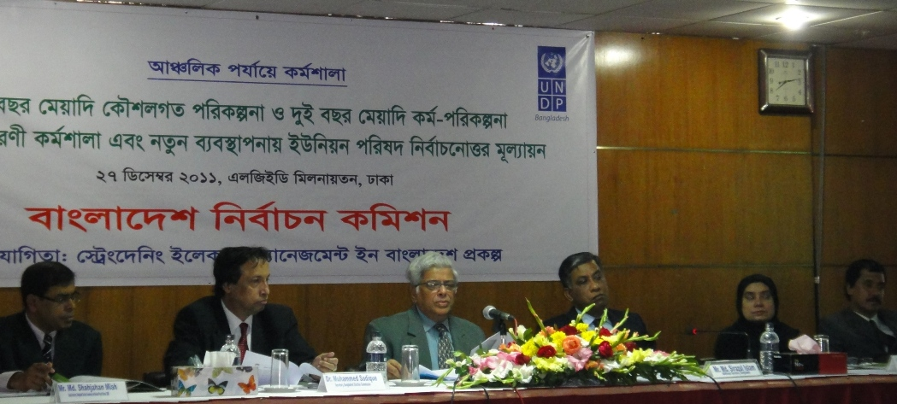
- Dissemination workshop on Five years strategic plan and Two years action plan: Bangladesh Election Commission recently formulated a Five-year Strategic Plan (2011-2016) and a Two-year Action Plan (2011-2013). BEC has identified a number of activities in order to achieve these strategic goals. SEMB project will provide support to BEC to implement these planned activities of Action Plan. A day long workshop held on 18 August 2011 in LGED auditorium, Chittagong with participation of election officials of various level of Chittagong and Comilla region. A total of 64 Election officials participated from Chittagong, Bandarban, Rangamati, Khagrachari, Cox’sbazar, Comilla, Feni, Laxmipur, Chadpur, Brahmanbaria, Noakhali districts. Dr. ATM Shamsul Huda, Chief Election Commissioner of Bangladesh Election Commission briefed to the election officials of Chittagong and Comilla region about the strategic plan.

A similar workshop was organized on 27 December 2011 in LGED Auditorium, Dhaka with Dhaka region election officials. A total of 47 officers from Dhaka, Manikgonj, Munsiganj, Narsingdi, Narayanganj and Gazipur districts were present in the dissemination workshop.

- Organogram and job description of BEC: A new organogram has been introduced in BEC secretariat and its field offices. In line with that, job description has been prepared for different wing and section of election commission secretariat. To finalize the job description for different level officers, a workshop was organized in HRDC, Koitta, Manikgonj from 23-25 September 2011. CEC Dr. ATM Shamsul Huda, Election commissioner Mr. Sohul Hossain, Mr. Sakhawat Hussain, Dr. Muhammed Sadique, secretary of Bangladesh Election Commission, Mr. Md. Sirazul Islam, Additional secretary of BEC, Mr. Md. Shahjahan Miah, Deputy Secretary of Bangladesh Election Commission and National Project Director of SEMB project, Mr. Md. Abdul Alim project coordinator of SEMB and relevant officers of BEC were present in the workshop. Through different group work officials finalized their job description which will help substantiate their role and responsibilities in performing their job. Based on this workshop, job description has been finalized and 1000 copies has been printed. Printed job description has been disseminated to secretariat and field level offices.

- Piloting of Voter list update process: BEC in support of Bangladesh Army prepared the electoral roll of all citizens of 18 years and above of Bangladesh in 2007-08. Recently, BEC decided to update the electoral roll and to do the job in specific and error-free way initiated a pilot project. In 1st phase piloting took place in Patnitala, Naogaon and Kaliganj, Gazipur from 12 July 2011. In 2nd phase it took place in Ward no 18, Dhaka City Corporation and Zhilongja union, Cox’sBazar from 13 August 2011. SEMB provided IT related support and monitored the piloting project.

- Narayanganj City Corporation (NCC) election: Narayanganj City Corporation (NCC) election held on 30 October 2011 in a free, fair and peaceful manner. SEMB project provided different support to hold the election participatory, transparent and accountable to the people of Narayanganj. SEMB supported to organize a live debate in BTV on 25 October 2011 with participation of all mayor candidates and they pledged for overall development of the city corporation; projection meeting with general and reserved councilors; dissemination of leaflets and posters on comparative statements of candidates. All these activities and information helped voters to analyze and choose their competent candidates in the election.

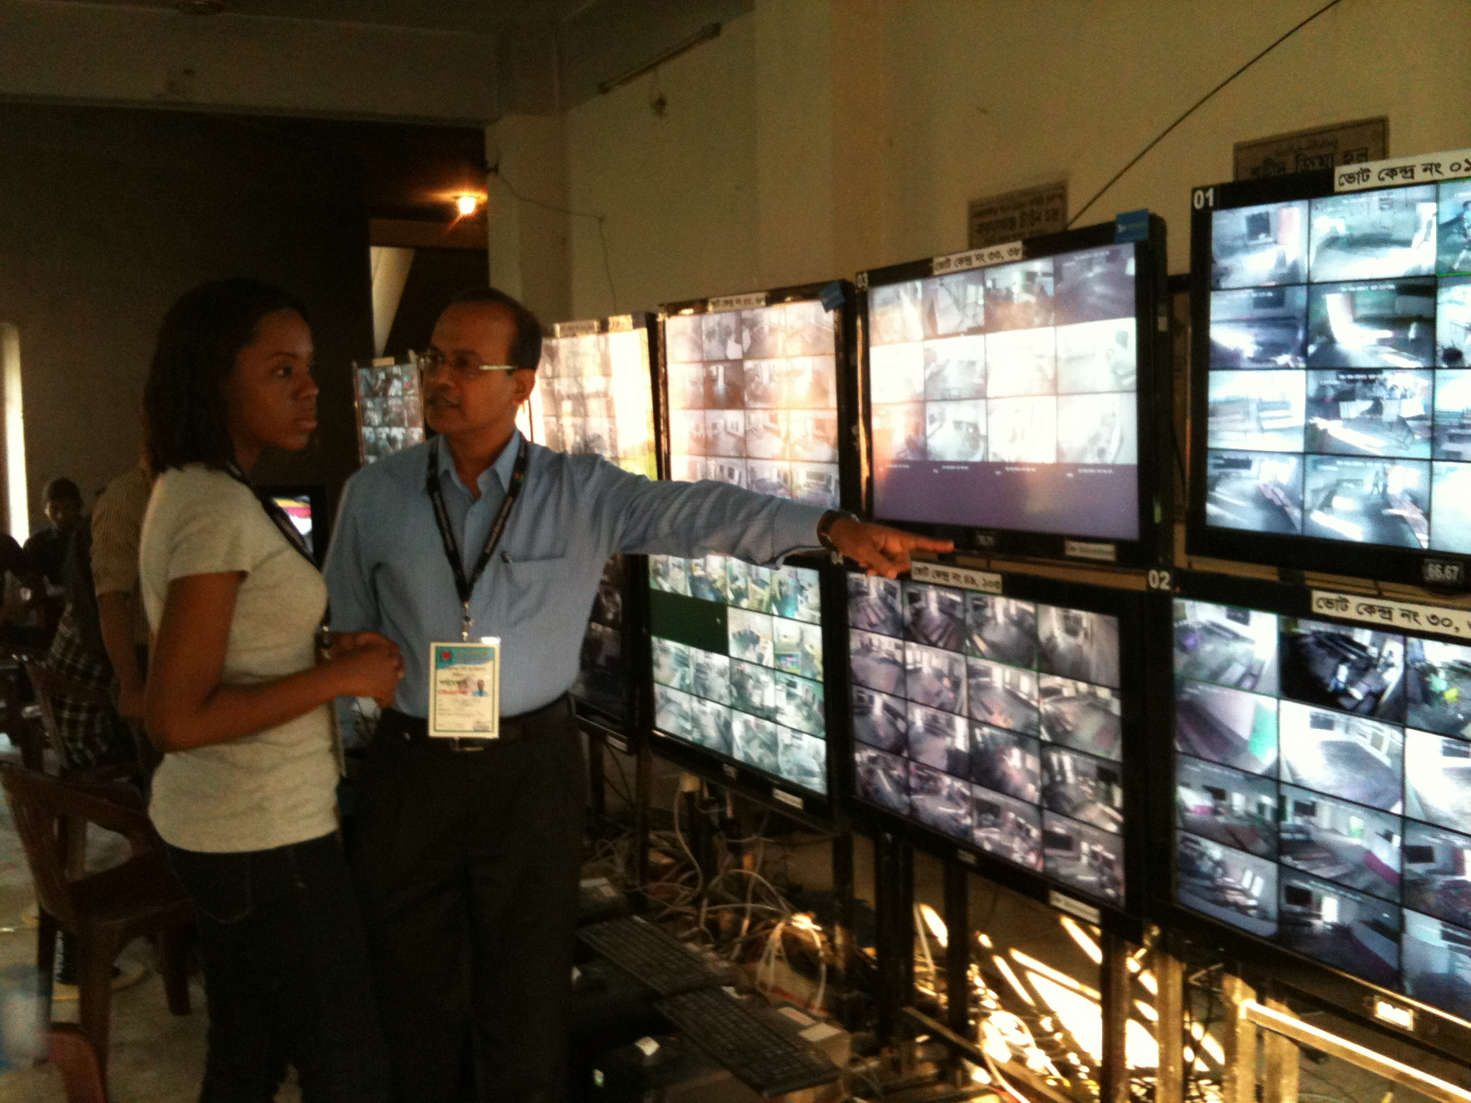
There were a total of 163 polling centers and 1217 polling booths. In the election day, among which 20 polling centers were covered through 170 CCTV camera for online monitoring and security management. The footage of these cameras were live telecasted to Shahid Zia hall (temporary Returning Officer’s office) and BEC secretariat in Dhaka. This online monitoring and security management of Narayanganj City Corporatoin (NCC) election through CCTV camera played a key role to hold the poll in non-violent and rigging free manner.
Photo: footage of CCTV camera telecasted in Zia Hall, Narayanganj from polling centers

Following from the preparatory assistance this project started 1 July 2011 and in the second half of 2011, the other key project start-up activities were:

- Recruitment processes have all been initiated.

- The Electoral Training Institute (ETI) has been relocated to more suitable and appropriate offices. The project has refitted these offices and fitted them out to create a learning environment in order that ETI with the support of the project is equipped to deliver high quality training and human resource investment.

- Provide support to BEC in preparing Technical Project Proposal and its approval.

- South-south cooperation was strengthened with project support and in cooperation with the Commonwealth the BEC hosted a workshop with peer body electoral commissions in South Asia and Africa to share experience and knowledge of voter registration systems.

- In July 2011, during the commencement of the project, BEC didn't have any Additional Secretary or Joint Secretary to recruit him/her as National Project Director (NPD). The project took an initiative to recruit an interim NPD to implement the project activities.
- The project provided support to SHUJAN, a civil society organisation, to build awareness among the voters to choose the right candidate.

Section 4: Lessons Learnt

In the course of implementation of project activities, a number of lessons were learnt including the following:

- Broad based consultation during the initial design of the SEMB project led to a relatively straight forward approval process of the final project document. This underscores the importance of consultation and national ownership in the design of projects.

- The existence of a preparatory assistance project (PA) prior to SEMB was critical to prevent a gap in support to the BEC and also provided the space for the development of a larger scale election support project. The PA proved instrumental in facilitating the start-up of the new SEMB project, notably with staff involved in key start-up operational activities for SEMB project implementation.

- Requisite timeframes and resources necessary to have a newly signed project up and running should be adequately factored into the first year annual work plans and the project’s expected results should realistically reflect this. Several activities planned for 2011 in SEMB had to be pushed back to 2012 given the delays in the project related to recruitment of staff and the location of new office facilities for ETI. The organisational restructuring of the BEC also slowed the implementation of some planned activities.

- The implementation in the early stages underscored how important early recruitment of key project staff can be to preventing project delays. A clear, prioritised human resource plan to guide the recruitment process is essential.

- Where appropriate, a project can be designed to promote the sustainability of past assistance. The SEMB project has been designed in this way and includes a component on voter registration to ensure the sustainability of the support provided through the PERP project. The design also allows for UNDP’s support to be systematically phased out as local capacity increases.

- Due to re-arrangement of the BEC staff and their promotion, some key planned activities were not implemented in 2011. The capacity building activities which were directly related to the staff development on specific areas (e.g. financial management training for financial staff) were postponed as the highest authority of the Commission suggested to wait until the re-arrangement is done.

- Delay in the recruitment of the international staff also made a bit impact on the implementation.
Section 5: Way Forward

The project’s direction will remain in line with the BEC’s five year strategic plan 2011-2016 and assistance will be provided to enhance the organisation’s capacity to deliver on its vision and mission. In 2012 there will be a considerable scaling up of project activities as it will be a crucial year for initiating key planning actions for the parliamentary elections in 2013. The project will focus on assisting the BEC to more systematically plan for these. Key assessments of departmental capacity/needs and a legal gap analysis will be conducted.

Assistance will be provided for the countrywide voter list update and efforts to strengthen the capacity of key wings of the BEC Secretariat will lie at core of envisioned initiatives. These will include provision of high quality training and curriculum design via ETI, development of electronic management systems for the financial and human resources branches of the BEC and ICT and communication capacity strengthened and equipped with strategic and implementation plans. The project will also have on board its full staffing requirements and it will have the capacity to deliver both annual outcome and output objectives.

According to Bangladesh Constitution, a new Commission will take the office in February 2012. So February and March would be the transition time and some planned activities might be delayed as the new Commission would need some time to understand the activities. In order to way out, the project needs to do huge interaction and move forward.

In 2011, the project had an interim NPD in the rank of Deputy Secretary. As the project document has the provision to recruit Additional/Joint Secretary, initiatives should be taken by the Country Office to recruit an NPD of higher level.

2012 is a crucial year for the project. The project has planned to complete many activities in this year. Well planning is very important for this and for smooth implementation; all recruitments must be completed immediately.

Annexure -1
List of knowledge products

1. Printing and publishing of Step by Step Guide and Election Journal
2. Printing and publishing of BEC Job Description
3. Printing and dissemination of leaflet on Electronic Voting Machine
4. Printing and publishing of Training Manual on EVM for Presinding and Assistant Presiding Officers

